Attendance by Facial Recognition

### Project Documentation

### 

## Supervisor

Mr. Muhammad Sajid

## Submitted by

Salman Masood

{05}

Umer Aslam

{09}

Ibrar Ahmad

{33}

BScs/8th (Evening)

Department of Computer Science & IT

The Islamia University of Bahawalpur, Bahawalnagar Campus

|  |  |  |  |
| --- | --- | --- | --- |
| Date (dd/mm/ivy) | Version | Description | Author |
| 09-05-2023 | 1.0 | The system utilizes a webcam for real-time image capture and processing, and machine learning-based software application that enables automatic recording of attendance using facial recognition technology. The project aims to eliminate the manual process of taking attendance, which can be time-consuming, prone to errors, and requires a significant amount of human resources. The proposed solution will automate the process and make it more efficient, accurate, and reliable. | Salman Masood (05)  Umer Aslam (09)  Ibrar Ahmad (33) |
|  |  |  |  |
|  |  |  |  |
|  |  |  |  |

Supervisor Name: ____________________

Designation: ____________________

Signature: ____________________

Contents

Project Documentation i

 i

Supervisor i

Submitted by i

Chapter:1 Introduction v

Overview 6

System features and functionalities: 6

Scope of Project 7

Objectives: 7

Chapter: 2 8

Related Systems 9

Flaws in Above Technology: - 9

Main flaws of above applications: 10

How above flaws cover by Our Application(SPA) 10

Chapter-3 11

Requirements: 12

2.1.1 Functional Requirement 12

Functional Requirements: 12

Reliability: 14

Availability: 14

Security: 14

Maintainability: 14

Use case: 14

Use-Case Scenarios 16

Use-case Scenario of Adding new person 16

Use-case Scenario of Take Attendance 17

Use-case Scenario of Update the database information: 18

System Requirements: 18

Adopted Methodology: - 19

Work Plan 20

Chapter: 3 21

Design and Development 22

Tools and Technologies 23

Project Perspective 23

System Study 24

Product Function 24

Feasibility Study 25

Financial Feasibility: 25

Technical Feasibility 25

Resource Feasibility 26

Methodology Diagram 27

Chapter:4 28

Test Cases: 29

Case # 1 29

Test Case # 2 30

Chapter:5 31

Interface Design: 32

Camera Activation 32

Detecting Image 33

Attendance Marked 34

Shows Already marked if duplicate attendance occurs 34

Chapter:6 35

Conclusion: 36

Chapter:7 37

References: 38

# Chapter:1 Introduction

## Overview

The system utilizes a webcam for real-time image capture and processing, and machine learning-based software application that enables automatic recording of attendance using facial recognition technology. The project aims to eliminate the manual process of taking attendance, which can be time-consuming, prone to errors, and requires a significant amount of human resources. The proposed solution will automate the process and make it more efficient, accurate, and reliable.

### System features and functionalities:

1. User-friendly interface for ease of use
2. High accuracy of facial recognition technology upto **99.4%.**
3. Fast and efficient attendance recording
4. Ability to integrate with existing attendance management systems
5. Real-time attendance tracking and reporting
6. Secure and reliable data storage
7. Automatic notifications to management in case of absentees or other anomalies

## Scope of Project

The facial recognition attendance system is a state-of-the-art technology that can revolutionize the way attendance is recorded in various settings. The system can be customized to meet the specific needs of each organization and can be integrated with existing attendance management systems. The system has the potential to reduce the time and effort required to maintain attendance records, while increasing accuracy and reliability. The scope of this project is to develop and implement a facial recognition attendance system for use in educational institutions, government offices, corporate workplaces, and other organizations that require accurate and reliable attendance records.

### Objectives:

* To develop a user-friendly facial recognition attendance system
* To provide a fast and efficient attendance recording mechanism
* To ensure high accuracy and reliability of attendance records
* To integrate with existing attendance management systems
* To provide real-time attendance tracking and reporting
* To ensure secure and reliable data storage
* To automate the notification process for absentees or other anomalies.

# Chapter: 2

Related System Analysis

## Related Systems

To solve the problem of attendance tracking, various solutions are already present in the market. Some of the most popular solutions include:

* Biometric Attendance Systems
* RFID-based Attendance Systems
* Manual Attendance Tracking

The problem of attendance tracking has been addressed by several existing solutions, including traditional manual attendance systems and automated attendance systems using biometric technology such as fingerprint or iris recognition. However, these systems have their disadvantages and limitations.

In terms of research, there have been several studies on the use of facial recognition technology for attendance tracking. A study published in the International Journal of Computer Applications in 2018 proposed an attendance management system that uses facial recognition technology. The system uses Haar-like features and Local Binary Pattern (LBP) histogram features for facial recognition. The system was found to be accurate and efficient, with an accuracy rate of 92.7.

## Flaws in Above Technology: -

Traditional manual attendance systems require the physical presence of an instructor or supervisor to take attendance manually, which is time-consuming and can be prone to errors.

Fingerprint recognition systems can be affected by factors such as dirt or moisture on the finger, which can affect the accuracy of the system. In addition, some individuals may have difficulty using fingerprint or iris recognition systems due to physical disabilities or injuries.

Facial recognition technology has also been used in attendance systems, which utilizes machine learning algorithms to recognize and identify individuals based on facial features. This technology has the advantage of being contactless, which is especially important during the COVID-19 pandemic. However, facial recognition technology also has its own set of limitations and concerns, including privacy and security concerns, as well as accuracy issues.

### Main flaws of above applications:

* Not user friendly
* Spreading of disease like COVID-19
* Not for physical disable persons
* Not flexible
* Non reliable

## How above flaws cover by Our Application(SPA)

1. User friendly: Our system is designed to be user-friendly, with a simple and intuitive interface that is easy to use for both administrators and users.
2. Reduced spread of disease: Since our system uses facial recognition technology, there is no need for physical contact with the attendance device, which reduces the risk of spreading diseases like COVID-19.
3. Accessibility: Our system is accessible to physically disabled persons as it does not require any physical contact or manual input.
4. Flexibility: Our system is highly flexible and can be easily customized to meet the specific needs of different organizations, such as different attendance policies and reporting requirements.
5. Reliability: Our system uses advanced facial recognition technology that is highly accurate and reliable, reducing the risk of errors in attendance records.

Chapter-3: System Analysis

**Introduction to Analysis:**

1. The Facial Attendance System is a software application designed to automate the process of taking attendance in a workplace or academic institution using facial recognition technology. The system identifies and records the attendance of employees or students by analyzing their facial features and comparing them to a pre-existing database of facial images. The system is intended to replace traditional manual attendance methods with a more accurate and efficient process.

## Requirements:

### 2.1.1 Functional Requirement

Functional requirements tell the basic behavior of system. They are **what** the system does or must not do, and can be thought of in terms of how the system responds to inputs. Functional requirements usually define if/then behaviors and include calculations, data input, and business processes.

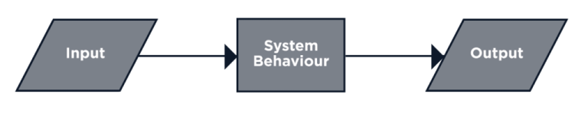

### 

### Functional Requirements:

#### FR-1

The system should be able to capture the facial image of a person in real-time using a camera or other image capturing devices.

#### FR-2

The system should be able to detect and recognize the face of a person accurately.

#### FR-3

The system should be able to match the recognized face with a pre-stored database of faces to identify the person.

#### FR-4

The system should maintain a log of the attendance of each recognized person along with their date and time.

#### FR-5

The system should be able to generate reports of attendance for each recognized person in a given period.

#### FR-6

The system should be able to send attendance reports to designated recipients through email or other communication channels.

#### FR-7

The system should be able to differentiate between authorized and unauthorized persons and generate alerts or notifications accordingly.

#### FR-8

The system should be able to handle multiple concurrent requests and ensure proper authentication and access control to the system and its data.

#### FR-9

The system should have a user-friendly interface for administrators to manage the system, including adding or deleting users, updating the database, and setting up attendance schedules.

#### FR-10

The system should ensure the privacy and security of the data collected, stored, and processed by the system.

*Non-***functional requirements:**

specify **how** the system should do it. Non-functional requirements do not affect the basic functionality of the system (hence the name, non-functional requirements). Even if the non-functional requirements are not met, the system will still perform its basic purpose.

**Performance:**

* The system shall exhibit high performance and response time, with minimal delays in recognizing and recording attendance.
* The facial recognition algorithm must be accurate and reliable, with a very low false positive and false negative rate.
* The system shall be able to handle a large number of users (students or employees) simultaneously without any performance degradation.

### Reliability:

* The system must be highly reliable, with a very low error rate in recognizing and recording attendance.
* The system must be able to handle system failures and errors gracefully, with minimal disruption to the attendance recording process.
* The system must ensure data integrity and prevent any unauthorized access or modifications to the attendance records.

### Availability:

* The system must be available at all times, with minimal or no downtime to ensure uninterrupted attendance recording.
* The system must be able to recover quickly from any hardware or software failures, and resume normal operations without any loss of attendance records.

### Security:

* The system must ensure the security and privacy of user data, with proper authentication and authorization mechanisms in place to prevent any unauthorized access.
* The system must comply with all relevant data protection laws and regulations, and use encryption to protect sensitive data.

### Maintainability:

* The system must be developed in a modular and scalable manner, to allow for easy maintenance and updates in the future.
* The system must be well-documented, with clear instructions for maintenance and troubleshooting.
* The system must be designed to be easily integratable with other systems and technologies, to ensure future compatibility and interoperability.

### Use case:

* The system should be easy to use, with a clear and simple user interface for recording attendance.
* The system should provide clear feedback to users on their attendance status and any errors or issues with the recognition process.
* The system should be able to generate reports and analytics on attendance records, to help in tracking and analyzing attendance patterns.

## Use-Case Scenarios

### Use-case Scenario of Adding new person

|  |  |  |
| --- | --- | --- |
| Use Case Title | Add a new person | |
| Use Case Id | 1 | |
| Requirement Id | - | |
| Description: This use case is for new user Registration | | |
| Pre-Conditions:   * 1. User Sign up for using application. | | |
| Task Sequence | | Exceptions |
| 1. Login by admin to add another person. | | System will show error if user enter incorrect or incomplete information in required field. |
| 1. System asks for necessary information. | |  |
| 1. Administrator provides all the required information and options to complete the operation. | |  |
| 1. There is a problem in the data provided; some data needs to be corrected.    * Administrator add the picture of new person with his detail. | |  |
| 1. System after confirmation adds the new account. | |  |
| Post Conditions:   * + A new user person data is successfully added. | | |
| Unresolved issues: The picture of the person should be clear and in 1:1 for best results. | | |
| Authority: Administrator | | |
| Author: Salman Masood (05), Umer aslam(09), Ibrar Ahmad (33) | | |

### 

### Use-case Scenario of Take Attendance

|  |  |  |
| --- | --- | --- |
| Use Case Title | **Attendance** | |
| Use Case Id | 2 | |
| Requirement Id | B2* | |
| Description: This use case is for take Attendance of the peroson which is registered. | | |
| Pre-Conditions:   1. Person should Registered before. 2. Person who is authorize to take attendance should be logged in . | | |
| Task Sequence | | Exceptions |
| 1. Person who take the attendence login the application. 2. The app displays a message "Active". | | System will show the error message if the login information will not matched with info which store in database. |
| 1. Camera took the snap student which is in front of camera. | |  |
| 1. Match with the database to validate the student. | |  |
| 1. Attendence is marked if it is present in the database. | |  |
| Post Conditions:  Teacher will be successfully login. | | |
| Unresolved issues: Take the attendance with the picture. | | |
| Authority: User/Teacher | | |
| Author: Salman Masood (05), Umer aslam(09), Ibrar Ahmad (33) | | |

### Use-case Scenario of Update the database information:

|  |  |  |
| --- | --- | --- |
| Use Case Title | Update Data | |
| Use Case Id | 3 | |
| Requirement Id | D3* | |
| Description: This use case is about updating the existing data of student/person. | | |
| Pre-Conditions:   1. Admin must signed in before update.. | | |
| Task Sequence | | Exceptions |
| 1. Delete the picture you want to update. 2. Add the new picture with its data. | |  |
| Post Conditions:  Data is successfully updated. | | |
| Unresolved issues: | | |
| Authority: Administrator | | |
| Author: Salman Masood (05), Umer aslam(09), Ibrar Ahmad (33) | | |

## System Requirements:

Windows 7,8,8.1,10,11

Any Windows machine with webcam or any camera sensor conpatible.

## Adopted Methodology: -

The Agile model is an iterative and incremental approach to software development that emphasizes collaboration, flexibility, and rapid delivery of working software. It is well-suited for FYPs as it allows for changes and updates to be made throughout the development process, which can be beneficial in a research-based project where requirements may evolve over time.

Moreover, the Agile model places a strong emphasis on teamwork and collaboration, which can help ensure that all stakeholders are involved and engaged throughout the development process. This can lead to a more cohesive and effective team, and ultimately, a better end product.

In addition, the Agile model also incorporates continuous feedback and testing, which can help identify and address issues early on in the development process, reducing the risk of delays or unexpected problems.

Overall, the Agile model offers a flexible and collaborative approach to software development that can be well-suited for FYPs, particularly those involving research and iterative development.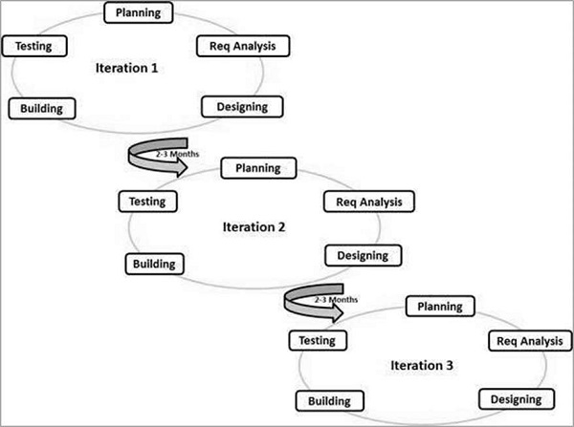

Below are other analyzed models with their respective grounds due to which these are not suitable for this project.

**Spiral:** The Spiral model is a risk-driven model that emphasizes the importance of risk management throughout the project lifecycle. While this is an important consideration in any project, it may not be as relevant for an FYP, which is typically smaller in scale and has fewer risks and uncertainties compared to a large-scale software development project.

**V-Model:** The V-Model is a variation of the Waterfall model that emphasizes the importance of testing and quality assurance throughout the development process. While testing is important in any software development project, it may not be as critical in an FYP, which may have a smaller user base and a shorter development timeline compared to large-scale software development projects.

Overall, the choice of model depends on various factors such as the scope, complexity, and requirements of your FYP. It's important to carefully consider these factors and choose a model that is best suited for your project's specific needs.

## Work Plan

Ghantt Chart:

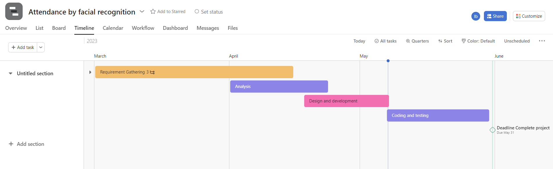

# Chapter: 3

Design

## Design and Development

1. Keep it simple: A clean and simple design can make the interface easy to navigate and understand.
2. Consistency: Use a consistent design across all the pages of your application to maintain a sense of unity and continuity.
3. Use color wisely: Color can help guide the user's attention and emphasize important elements, but use it sparingly and purposefully. Make sure the colors are not too bright or overwhelming, as it can make the interface difficult to use.
4. Consider the user: Your design should be user-friendly, meaning it should be easy to understand and navigate for the target audience. Make sure to consider the users' needs and preferences when designing the interface.
5. Use icons and images: Icons and images can help users understand what actions they can take on the interface. Use clear and recognizable icons and images to convey meaning and improve the user experience.
6. Test and refine: Once you have a basic design, test it with potential users to identify areas of improvement. Refine the design based on feedback to create an optimal user experience.

## Tools and Technologies

1. For the implementation of the attendance system using facial recognition, we will use the following tools and technologies:
2. Python: We will use the Python programming language for developing the software application. Python provides a rich set of libraries and frameworks that can be used for various tasks, including image processing, machine learning, and data manipulation.
3. Face Recognition Library: We will use the Face Recognition library, which is a Python library that provides face recognition capabilities using deep learning models. This library is built using dlib's state-of-the-art face recognition built with deep learning, which has an accuracy of 99.38% on the Labeled Faces in the Wild benchmark.
4. OpenCV: We will use OpenCV, an open-source computer vision library, for face detection and image processing tasks. OpenCV provides various functions for image and video analysis, including face detection and feature extraction.
5. Excel: We will use Excel for storing and managing attendance data. The attendance system will mark attendance in an Excel file with the timestamp, which can be used for further analysis and reporting.
6. Webcam: We will use a webcam to capture the images of the individuals and recognize their faces using the Face Recognition library.
7. Overall, these tools and technologies will enable us to develop an efficient and accurate attendance system using facial recognition.

## Project Perspective

Automate the attendance-taking process and make it more efficient, accurate, and convenient for both students and instructors. By using facial recognition technology, students can simply stand in front of a camera, and their attendance will be automatically marked. This eliminates the need for manual attendance-taking, which can be time-consuming and prone to errors. Additionally, this system can help prevent students from cheating the attendance system, as it is more difficult to impersonate someone else's face than to sign in for them.

Your GUI design should reflect these benefits and make it easy for users to understand and use the system. You should aim for a clean and simple interface that guides users through the process of taking attendance. Consider including visual feedback to let students know that their attendance has been successfully recorded, and providing instructors with tools to manage attendance records, such as the ability to generate reports or view attendance statistics.

Overall, the GUI design of your FYP should prioritize usability and functionality to make the attendance-taking process as streamlined and efficient as possible.

## System Study

System study is a detailed study of a various operations performed by a system and their relationships within and outside the system.

System study can be categorized into four parts.

* System planning
* Initial Investigation
* Proposed System with Objective
* Feasibility Study

## Product Function

Detect Face: This function would detect the face in the image captured by the camera. This function could use OpenCV's Haar Cascades or deep learning models to detect faces.

Capture Image: This function would capture an image of the face detected by the "Detect Face" function. The captured image would then be processed by the facial recognition algorithm.

Facial Recognition: This function would match the captured image with the images stored in the database to determine the identity of the person. This function could use machine learning algorithms such as support vector machines, neural networks, or deep learning models to recognize the face.

Mark Attendance: This function would mark the attendance of the person whose identity has been recognized by the "Facial Recognition" function. This function would update the attendance database with the date and time of the attendance.

Attendance Report: This function would generate a report of the attendance data stored in the database. The report would contain information such as the date, time, and name of the person who marked the attendance. This report can be exported in different formats such as Excel, CSV, or PDF.

Database Management: This function would manage the database of the system. It would allow adding, editing, and deleting records of the students or employees.

## Feasibility Study

### Financial Feasibility:

Here is an example of a financial feasibility report for your FYP (Facial Attendance System by Facial Recognition).

#### Cost Estimation:

Hardware Costs:

* Camera: PKR 1500/-
* Mid-performance Computer: PKR 30000/-
* Software Costs: Yet to deside.

OpenCV library: Free

Face recognition algorithm: Free

Custom Development costs: 40000/-

Operational costs: 1000/month (Electricity Etc..)

### Technical Feasibility

Our projectis a complete windows-based application.

1. Hardware: The system requires a reliable and high-performance hardware configuration to ensure smooth operations. The hardware components should be compatible with the software and should meet the recommended system requirements.
2. Software: The facial recognition software should be reliable and accurate in recognizing faces. The software should be compatible with the hardware and should be able to work in real-time. The software should be designed to handle large volumes of data and should be able to generate reports as per the user's requirements.
3. Network Infrastructure: The system should be able to work seamlessly over the network infrastructure. The network should be robust and should have high bandwidth to ensure real-time communication between the client and the server.
4. Database Management: The system should have a well-designed database management system that can store and retrieve data efficiently. The database should be scalable and should be able to handle large volumes of data. The system should have proper backup and disaster recovery mechanisms in place to ensure data safety.
5. User Interface: The system should have an intuitive and user-friendly interface. The interface should be designed to provide easy access to all the functionalities of the system. The system should have proper documentation and training materials to ensure that the users can use the system effectively.

### Resource Feasibility

Resources that are required for the **project** includes,

* Programming Device (Laptop).
* Cameara sensor(Webcam).
* Hosting Space (Freely available).
* Programming tool (Freely available).
* Programming individuals.

### Methodology Diagram

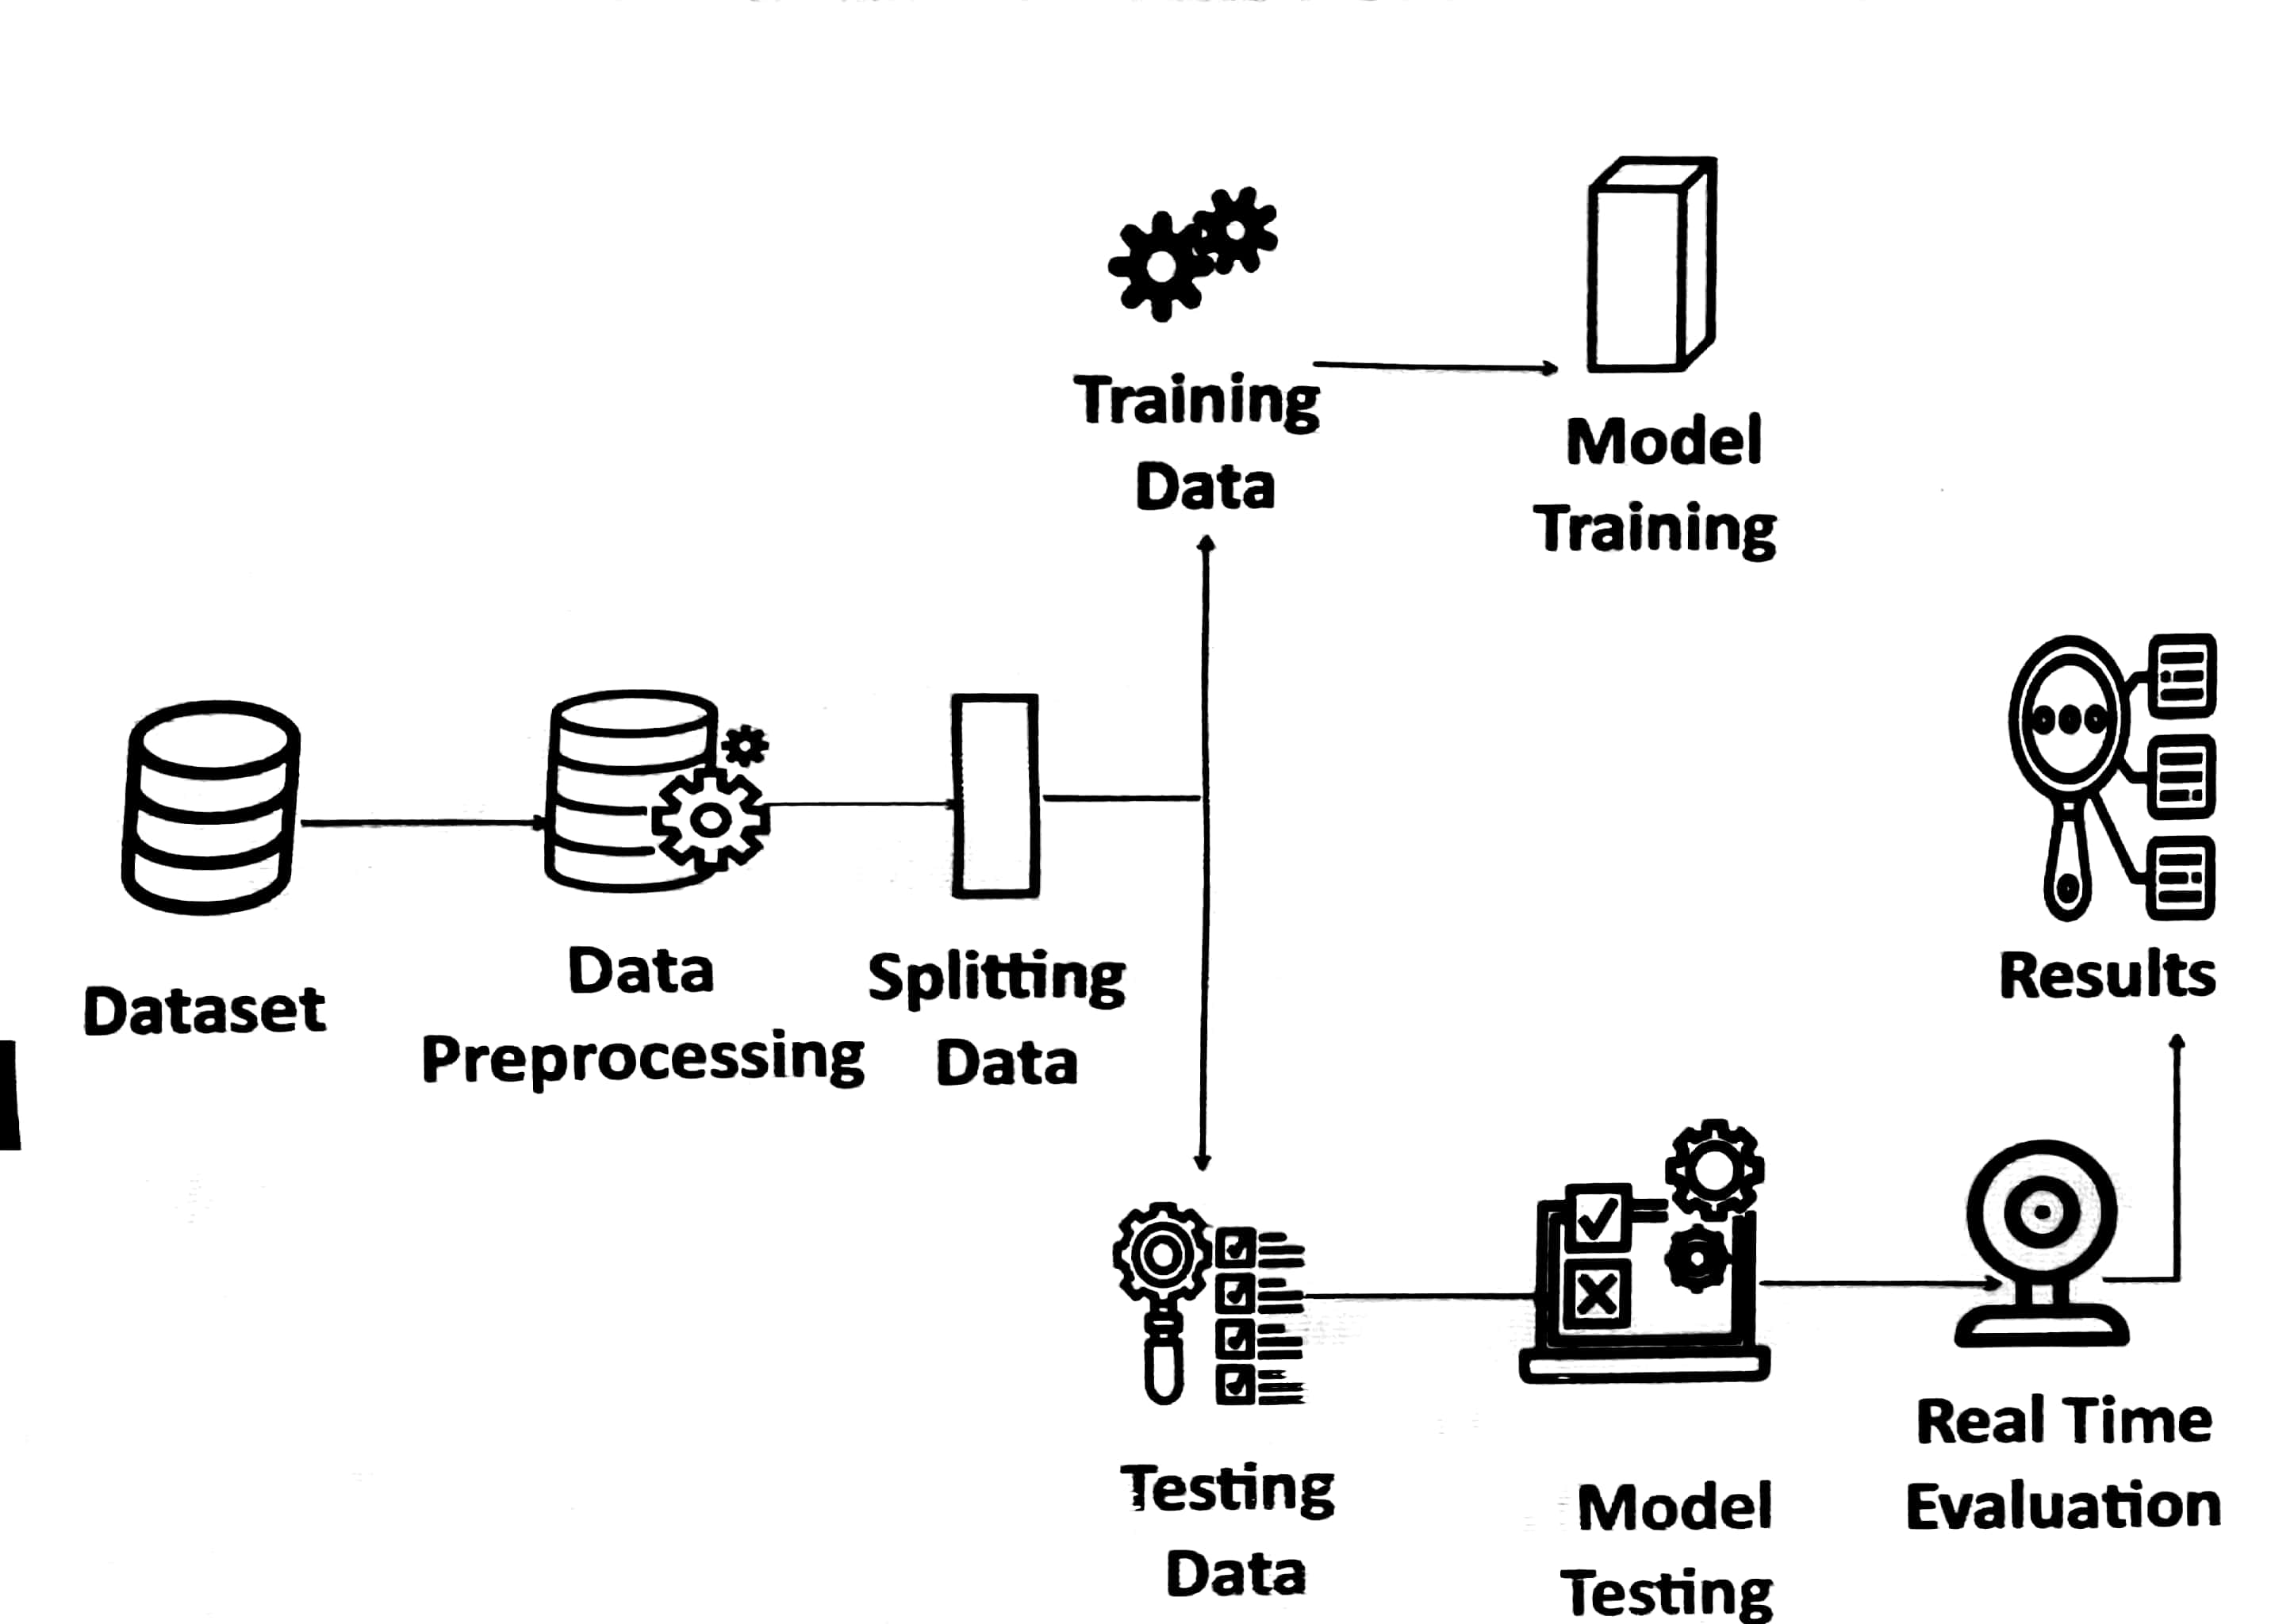

* Identifying a person based on key parameters
* Verifying his identity and authorization using the database

# Chapter:4

Testing

# 

# Test Cases:

## Case # 1

**Test Case Title:** Admin

|  |  |
| --- | --- |
| Preconditions | * 1. User must have a computational device on which he/she run the application. |
| Actions | 1. Install Pychrm or jupyter notebook  2. Install Python  3. Add the pictures of students of class.  4. Run the code |
| Expected Results | User can see the screen which shows the real time footage of camera. |
| Tested By: | Ibrar Ahmad, Salman masood, Umer Aslam |
| Result | Pass |

Table 1: For Admin

## Test Case # 2

**Test Case Title:** Attendance(User)

|  |  |
| --- | --- |
| Preconditions | User must have a computational device on which he/she run the application. |
| Actions | 1. Click on Take Attendance 2. Camera Activates 3. Capture the person’s face 4. Marked his/her attendance if it is present in database. 5. Shows “Attendence Maked” 6. Again Camera Actives |
| Expected Results | User attendence is marked succesfully with the accuracy. |
| Tested By: | Ibrar Ahmad, Salman masood, Umer Aslam |
| Result | Pass |

Table 2: Attendance(User)

# Chapter:5

GUI

# Interface Design:

## Camera Activation

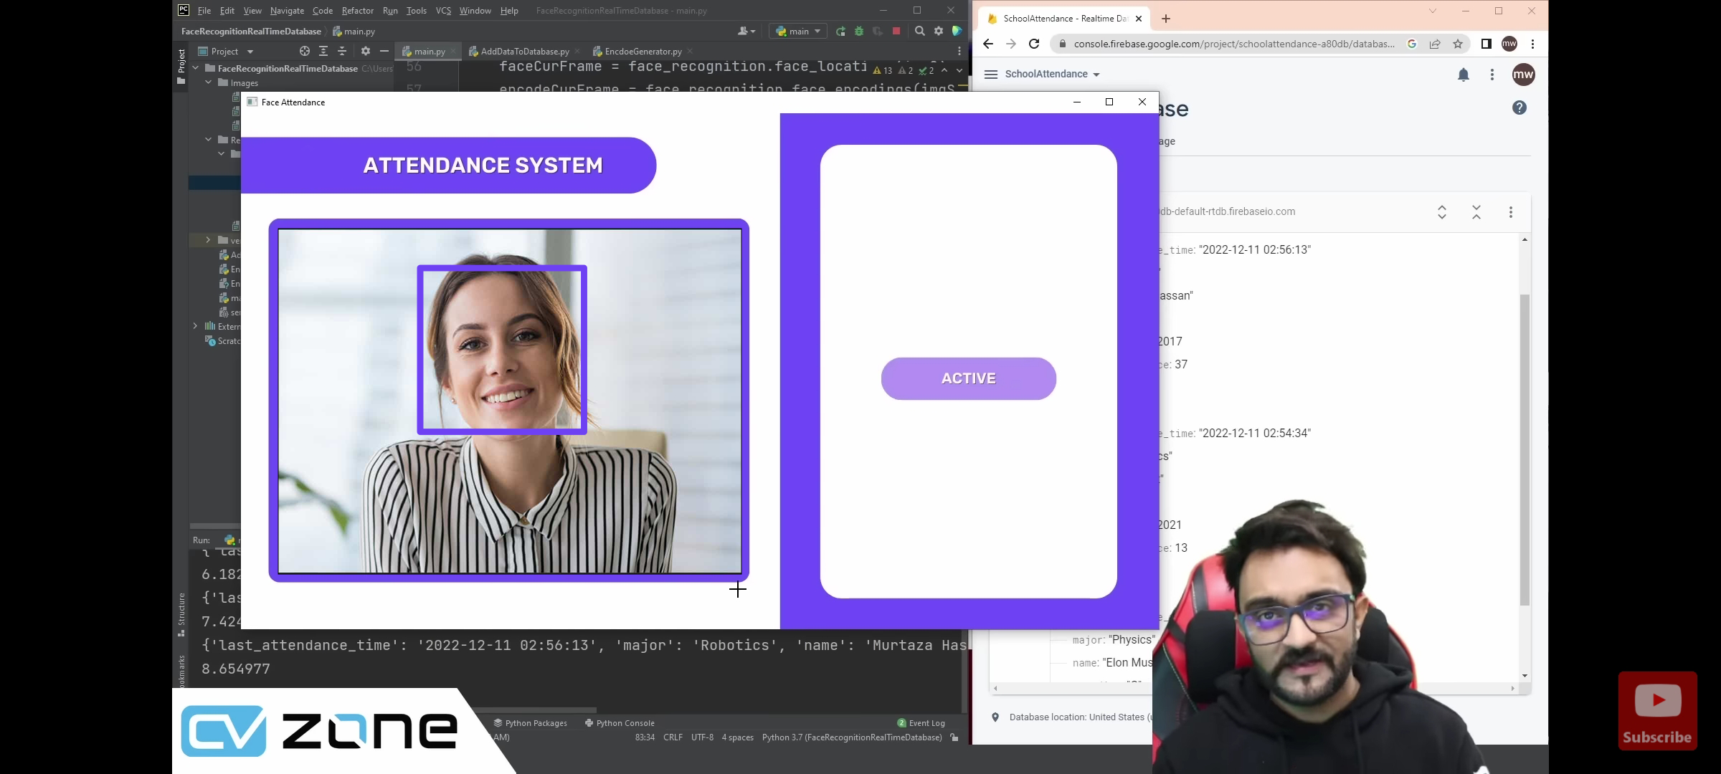

Detecting Image

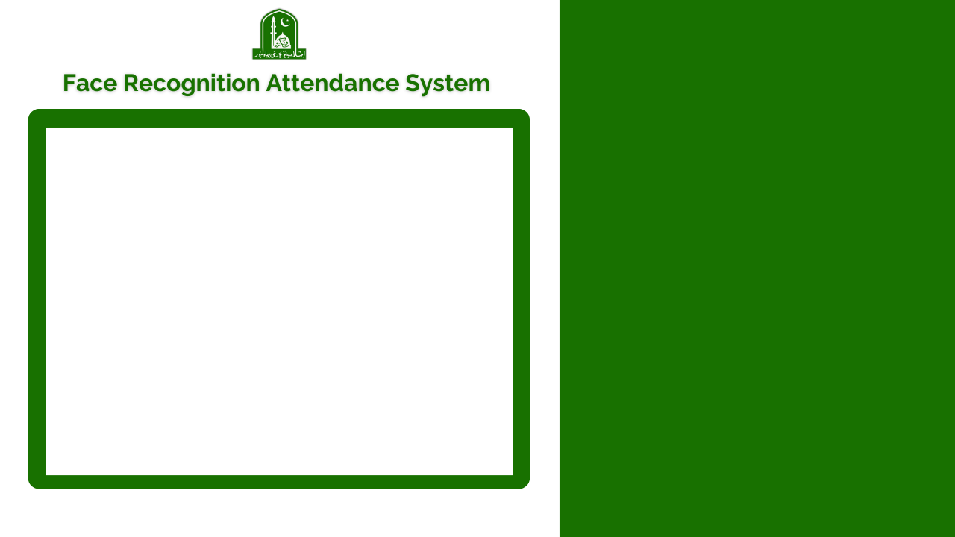

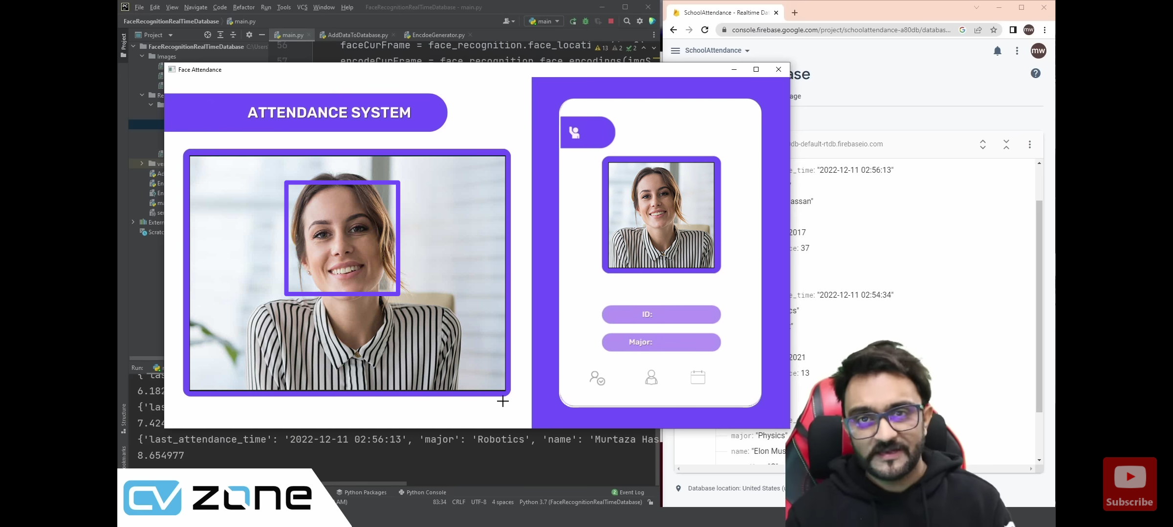

## Attendance Marked



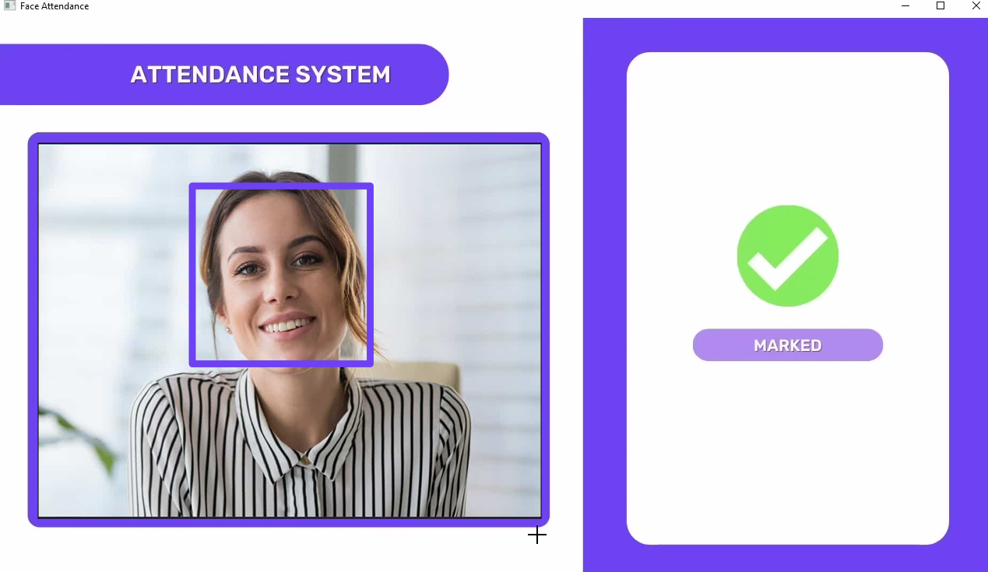

## Shows Already marked if duplicate attendance occurs



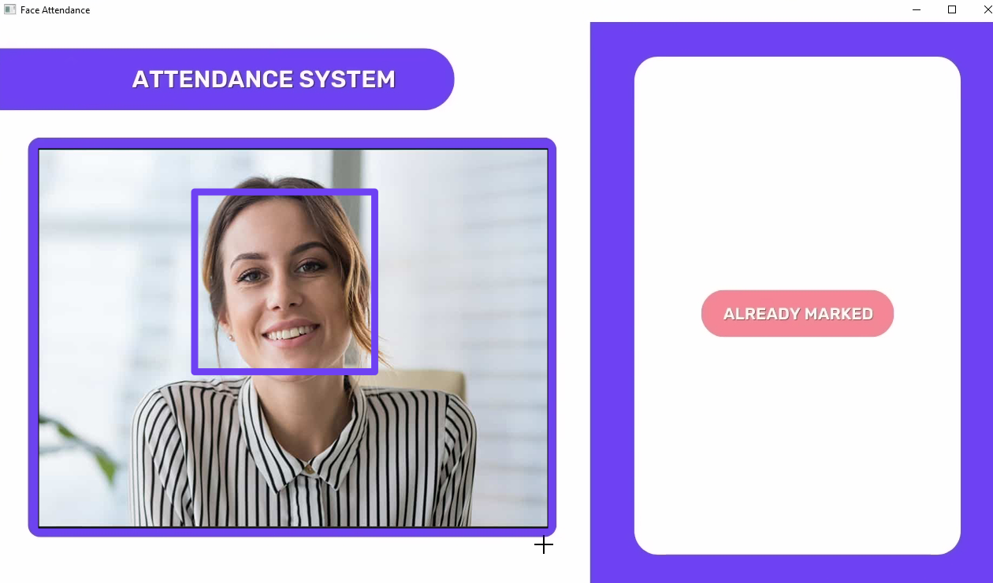

# Chapter:6

Conclusion

### Conclusion:

In conclusion, the proposed attendance system using facial recognition technology has the potential to revolutionize attendance tracking and management for various organizations. By utilizing state-of-the-art deep learning algorithms and the FACE RECOGNITION library, the system can accurately detect and recognize faces in real-time, and automatically record attendance in an Excel file with a timestamp. The system is designed to be user-friendly, efficient, and reliable, and can eliminate the need for manual attendance tracking. The proposed solution can provide significant benefits, including improved attendance management, cost savings, and enhanced data analytics capabilities. With the proposed methodology and architecture, the attendance system can be developed and implemented with ease. However, it is important to consider the privacy and security concerns associated with facial recognition technology and take appropriate measures to address them. Overall, the attendance system using facial recognition technology is a powerful and innovative solution that has the potential to transform attendance tracking and management.

# Chapter:7

References

# References:

Face Recognition Attendance System Using OpenCV and Python

https://www.geeksforgeeks.org/face-detection-using-python-and-opencv-with-webcam/

Face Recognition Attendance System Using LBP and PCA

https://www.researchgate.net/publication/333134486_Face_recognition_attendance_system_using_Local_Binary_Pattern_LBP

Face Recognition Attendance System Using Eigenfaces

https://www.mathworks.com/matlabcentral/fileexchange/66869-facial-recognition-system-using-eigenfaces-and-svm

Face Recognition Attendance System

https://www.youtube.com/watch?v=JDKzHt6vbJM

Face Recognition Attendance System Using Gabor Features

https://www.youtube.com/watch?v=JDKzHt6vbJM

Face Recognition Attendance System Using Deep Learning

https://www.ijraset.com/research-paper/facial-recognition-attendance-system-using-deep-learning

Face Recognition Attendance System Using Keras

https://m.youtube.com/watch?v=lH01BgsIPuE

Face Recognition Attendance System Using TensorFlow Lite

https://github.com/theonlyNischal/Classroom-Attendance-System-Utilizing-Viola-Jones-for-Face-Detection-and-LBPH-for-Face-Recognition

Face Recognition Attendance System Using OpenCV and Android

<https://m.youtube.com/watch?v=vHuM6hkHMxE>

Library used in our system: https://pypi.org/project/face-recognition/

https://en.wikipedia.org/wiki/COVID-19

https://www.python.org/